Day 43 – XOR Gate Using MUX

Introduction: Implemented an XOR Gate using Multiplexers (MUX).
The XOR gate was implemented using:
- 2:1 MUX
- 4:1 MUX

1. XOR Gate Using 2:1 MUX

Design
For the 2:1 MUX:
- I0 = A
- I1 = ~A
- S = B

Design Code:

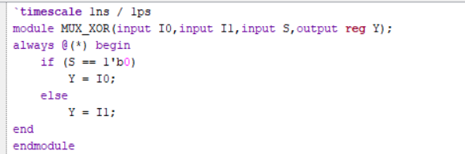

Testbench: The testbench checks all possible combinations of inputs A and B.

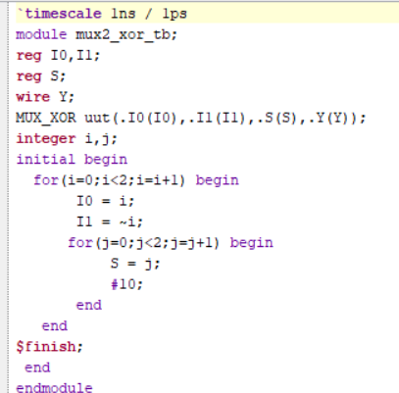

Waveform: The waveform verifies the correct XOR gate operation.

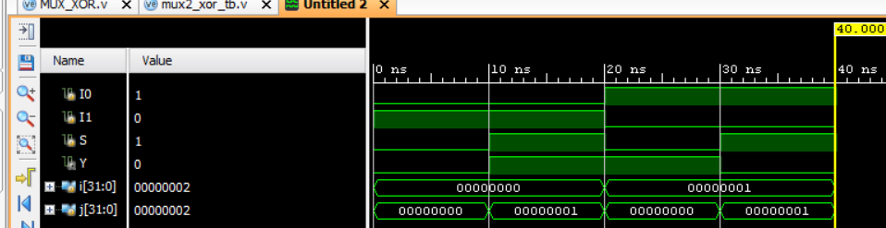

Schematic:

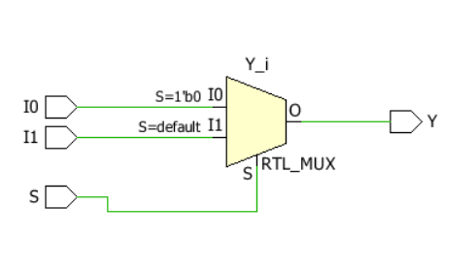

2. XOR Gate Using 4:1 MUX

Design: For the 4:1 MUX, the inputs are connected according to the XOR operation:
- I0 = 0
- I1 = 1
- I2 = 1
- I3 = 0

Design Code:

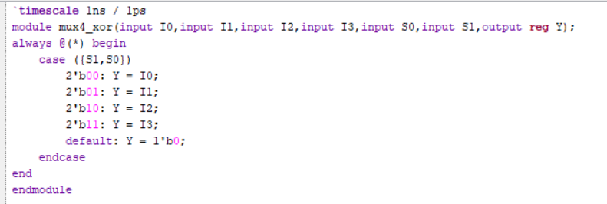

Testbench: The testbench uses a for loop to check all four combinations of the select inputs.

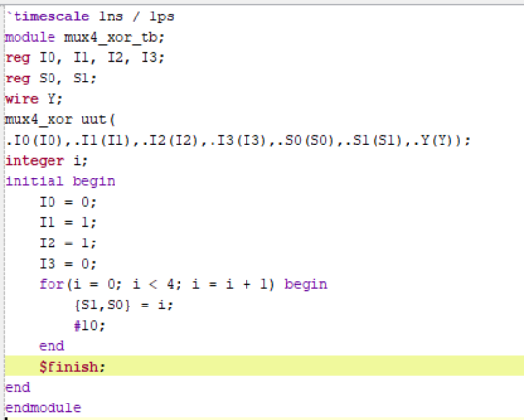

Waveform: The waveform verifies the correct XOR gate operation.

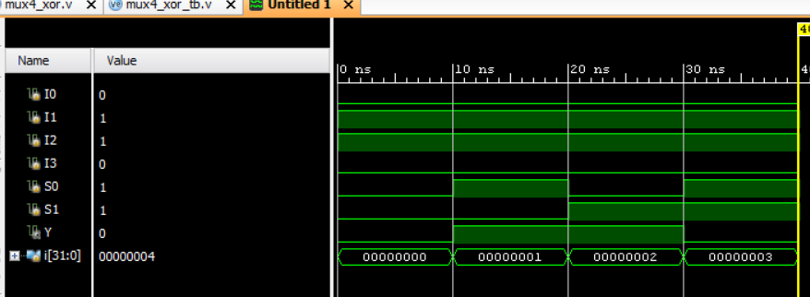

Schematic:

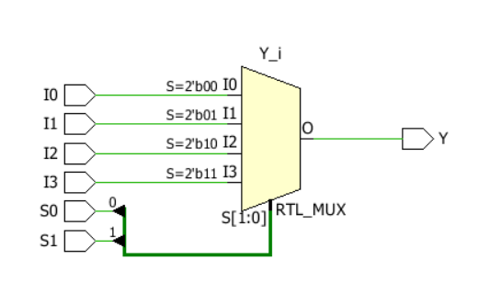

Observation
- The XOR gate was successfully implemented using 2:1 and 4:1 MUXes.
- For the 2:1 MUX, I0 = A, I1 = ~A, and B was used as the select input.
- For the 4:1 MUX, the inputs were connected as I0=0, I1=1, I2=1, I3=0.
- The waveforms verify the expected XOR gate operation.
- The output is 1 when the two inputs are different.

#PHANEENDRA.SINGUDASU

